Tolstoy, Anna Karenina Bobbs Merrill, stated First Printing 1978 Art by Warren Chappell, Good, unclipped DJ with faded “Leo.” VG hardcover with markings - a symbol on side and bottom edges and the name of former owner on first page. ISBN 0672523833

ID 000110 Price $16.50

*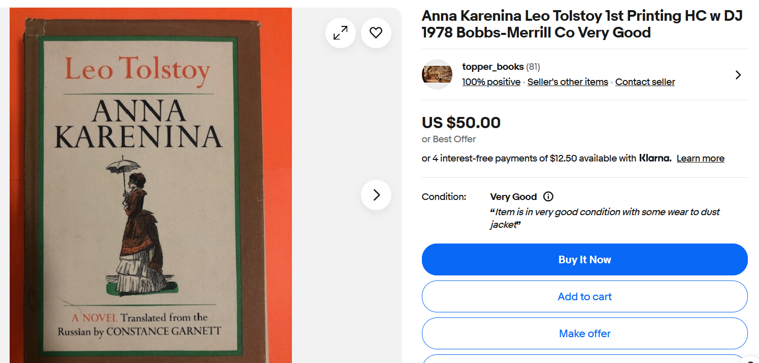
Ebay, also at $7.96 lowest price on scouter
BookFinder New $100 to $280; used $7 to

